**Connecting All The Components**

**Step One: Wiring Everything Together**

(*refer to last page for help with pins on the Raspberry Pi)*

To start you will want to have finished every tutorial before this and have the Raspberry Pi and Arduino boards configured like they are at the end of the Turbidity Sensor Tutorial. Also make sure to have the camera connected. If you need assistance refer back to the camera tutorial. Before starting your Raspberry Pi should resemble this:

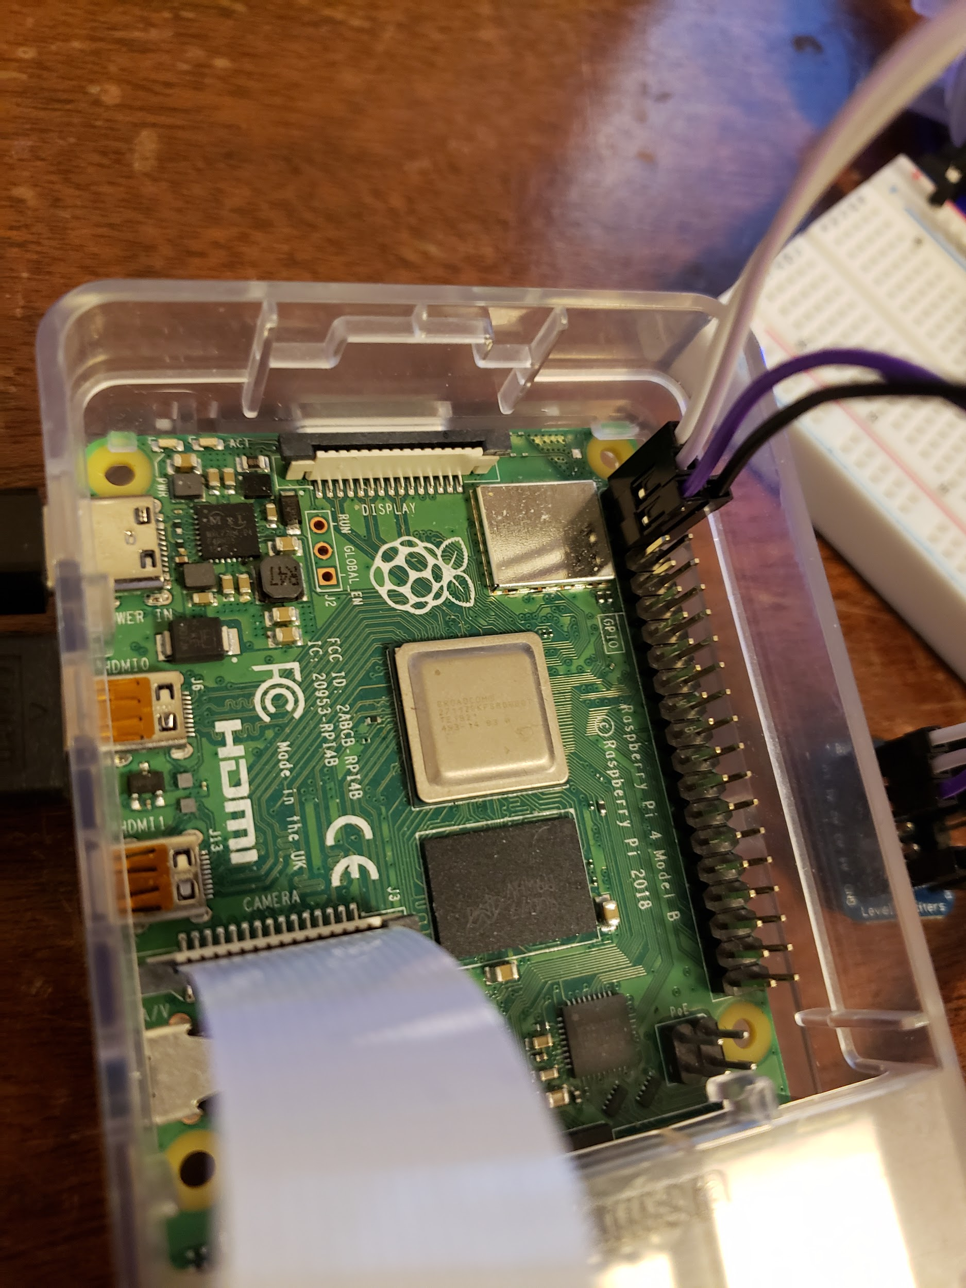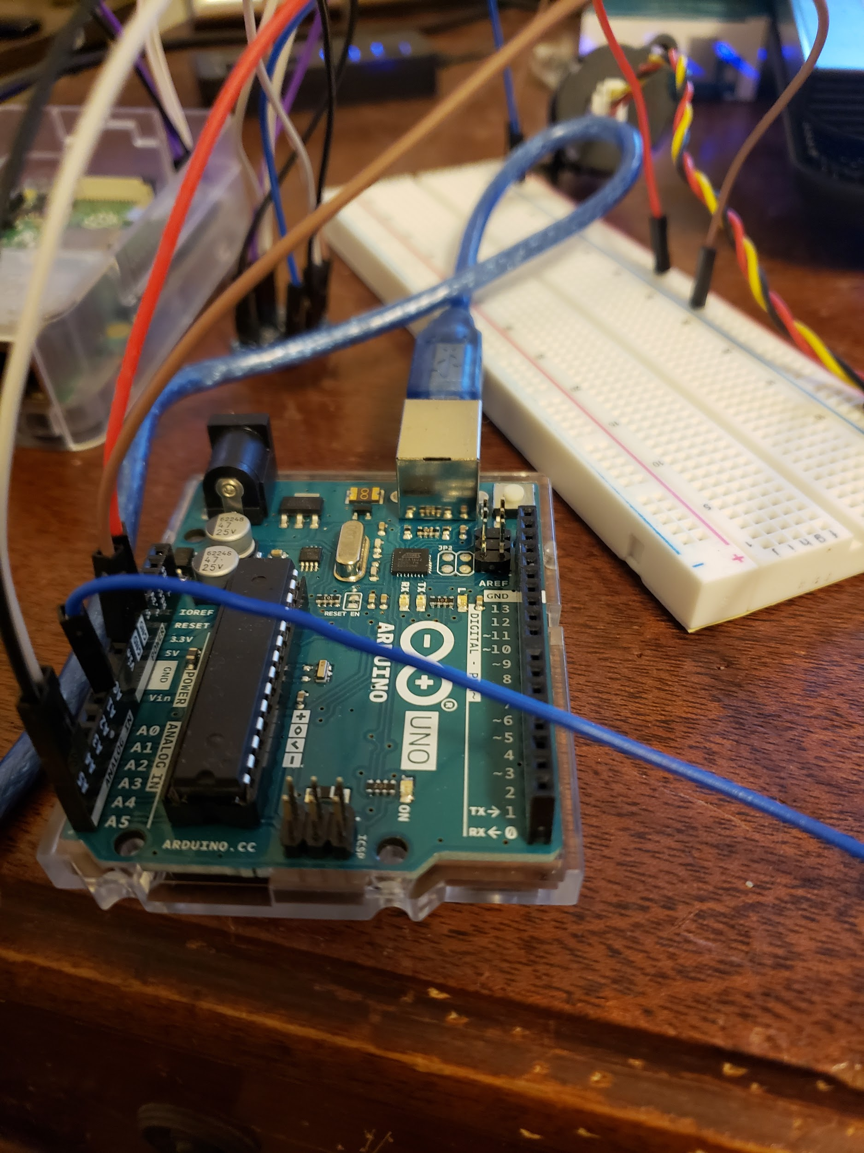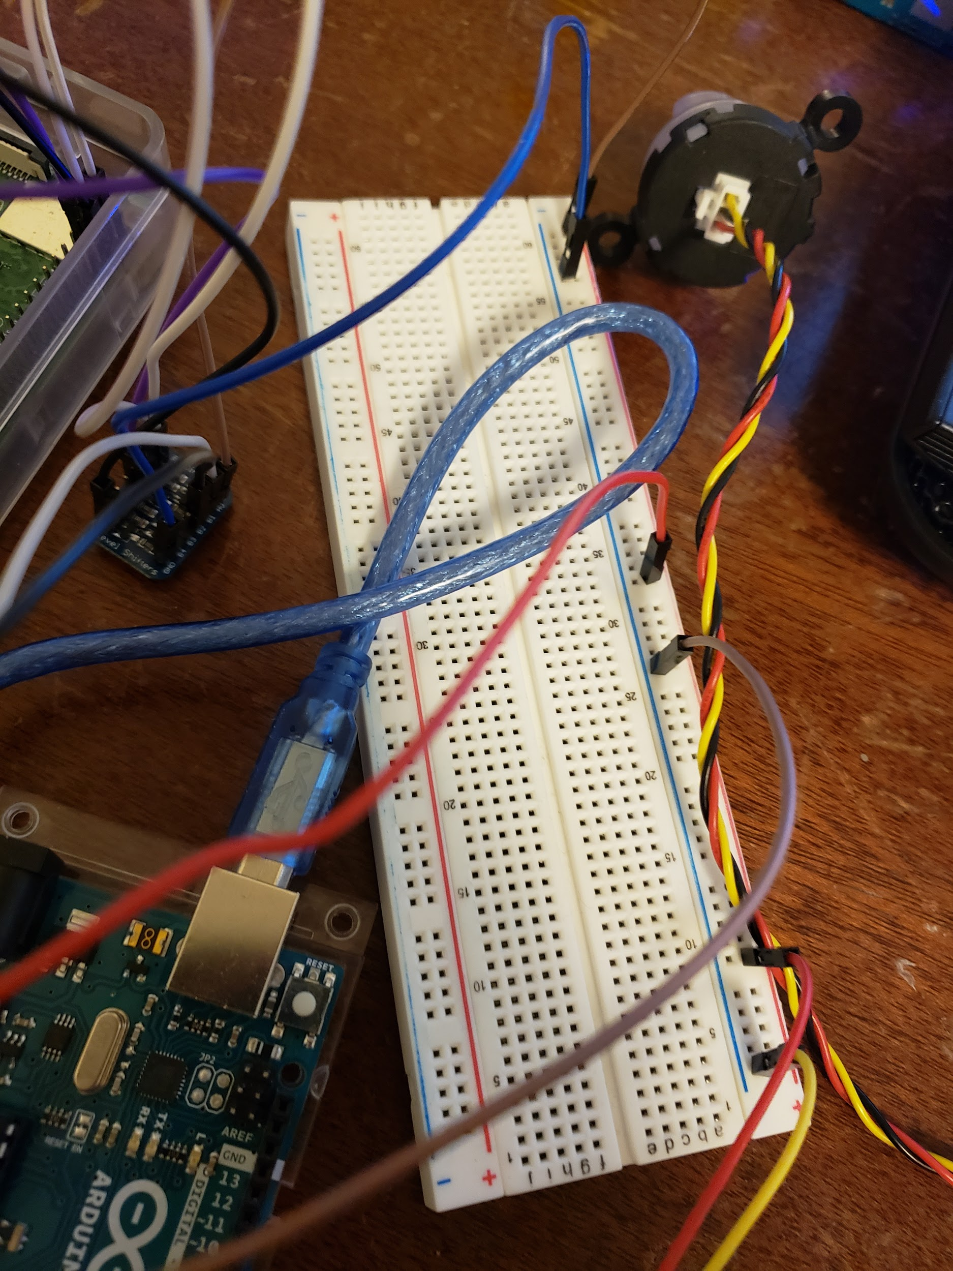

Next assuming you have completed the thermometer tutorial. You should have the thermometer connected to a breadboard that looks something like this:

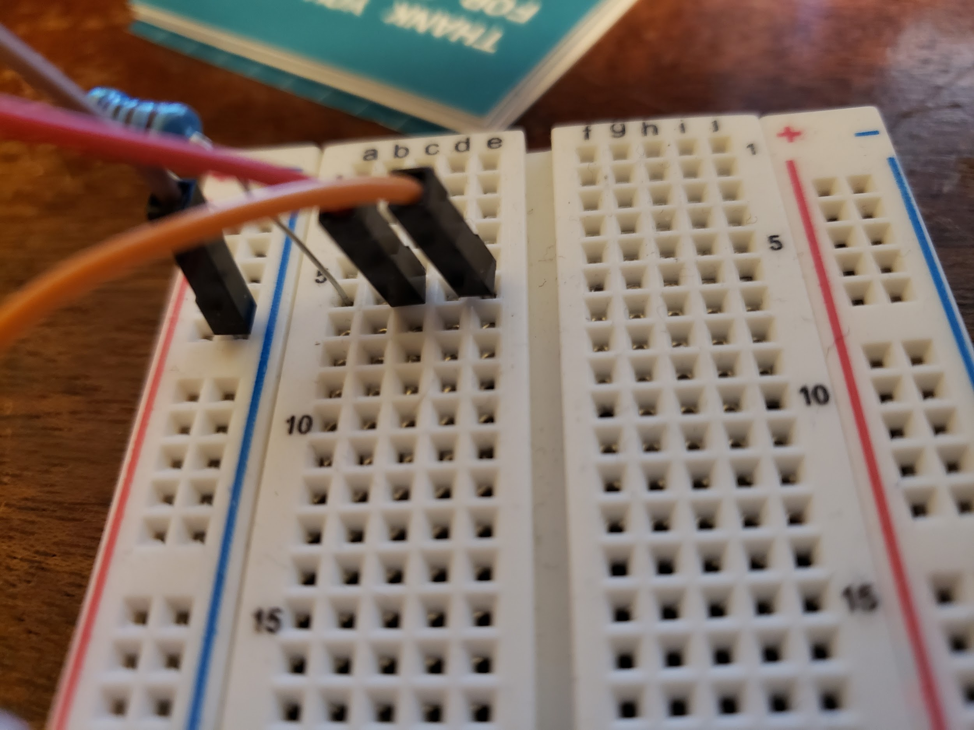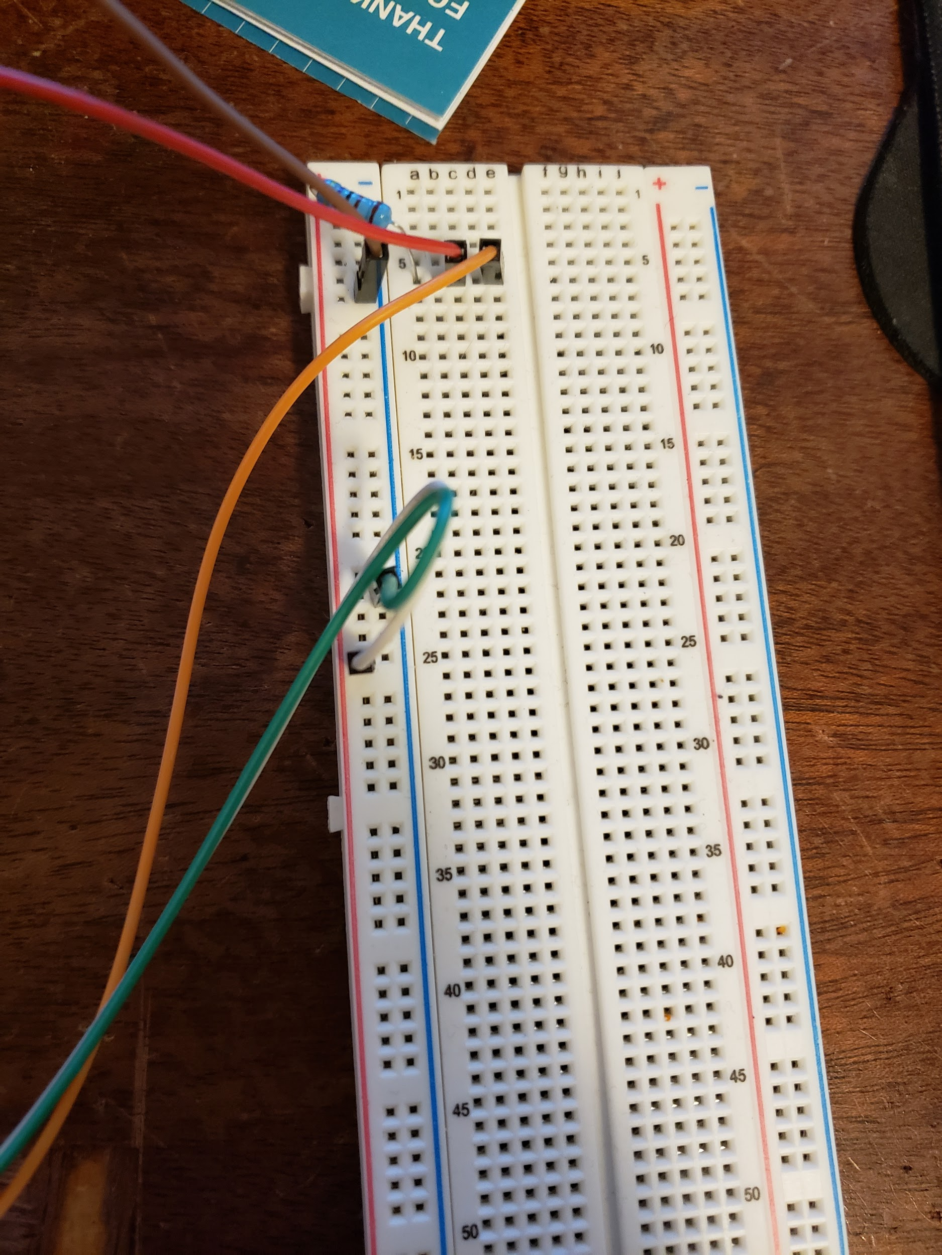

The only difference between the picture here and the one in the tutorial is that this one is lacking a power connection. This will be explained in the next few steps.

Once here we will also need the light sensor from the previous tutorial which should have three connections two being female to female and one being female to male. The one female to male cable will be connected to the power pin on the sensor. Something like this:

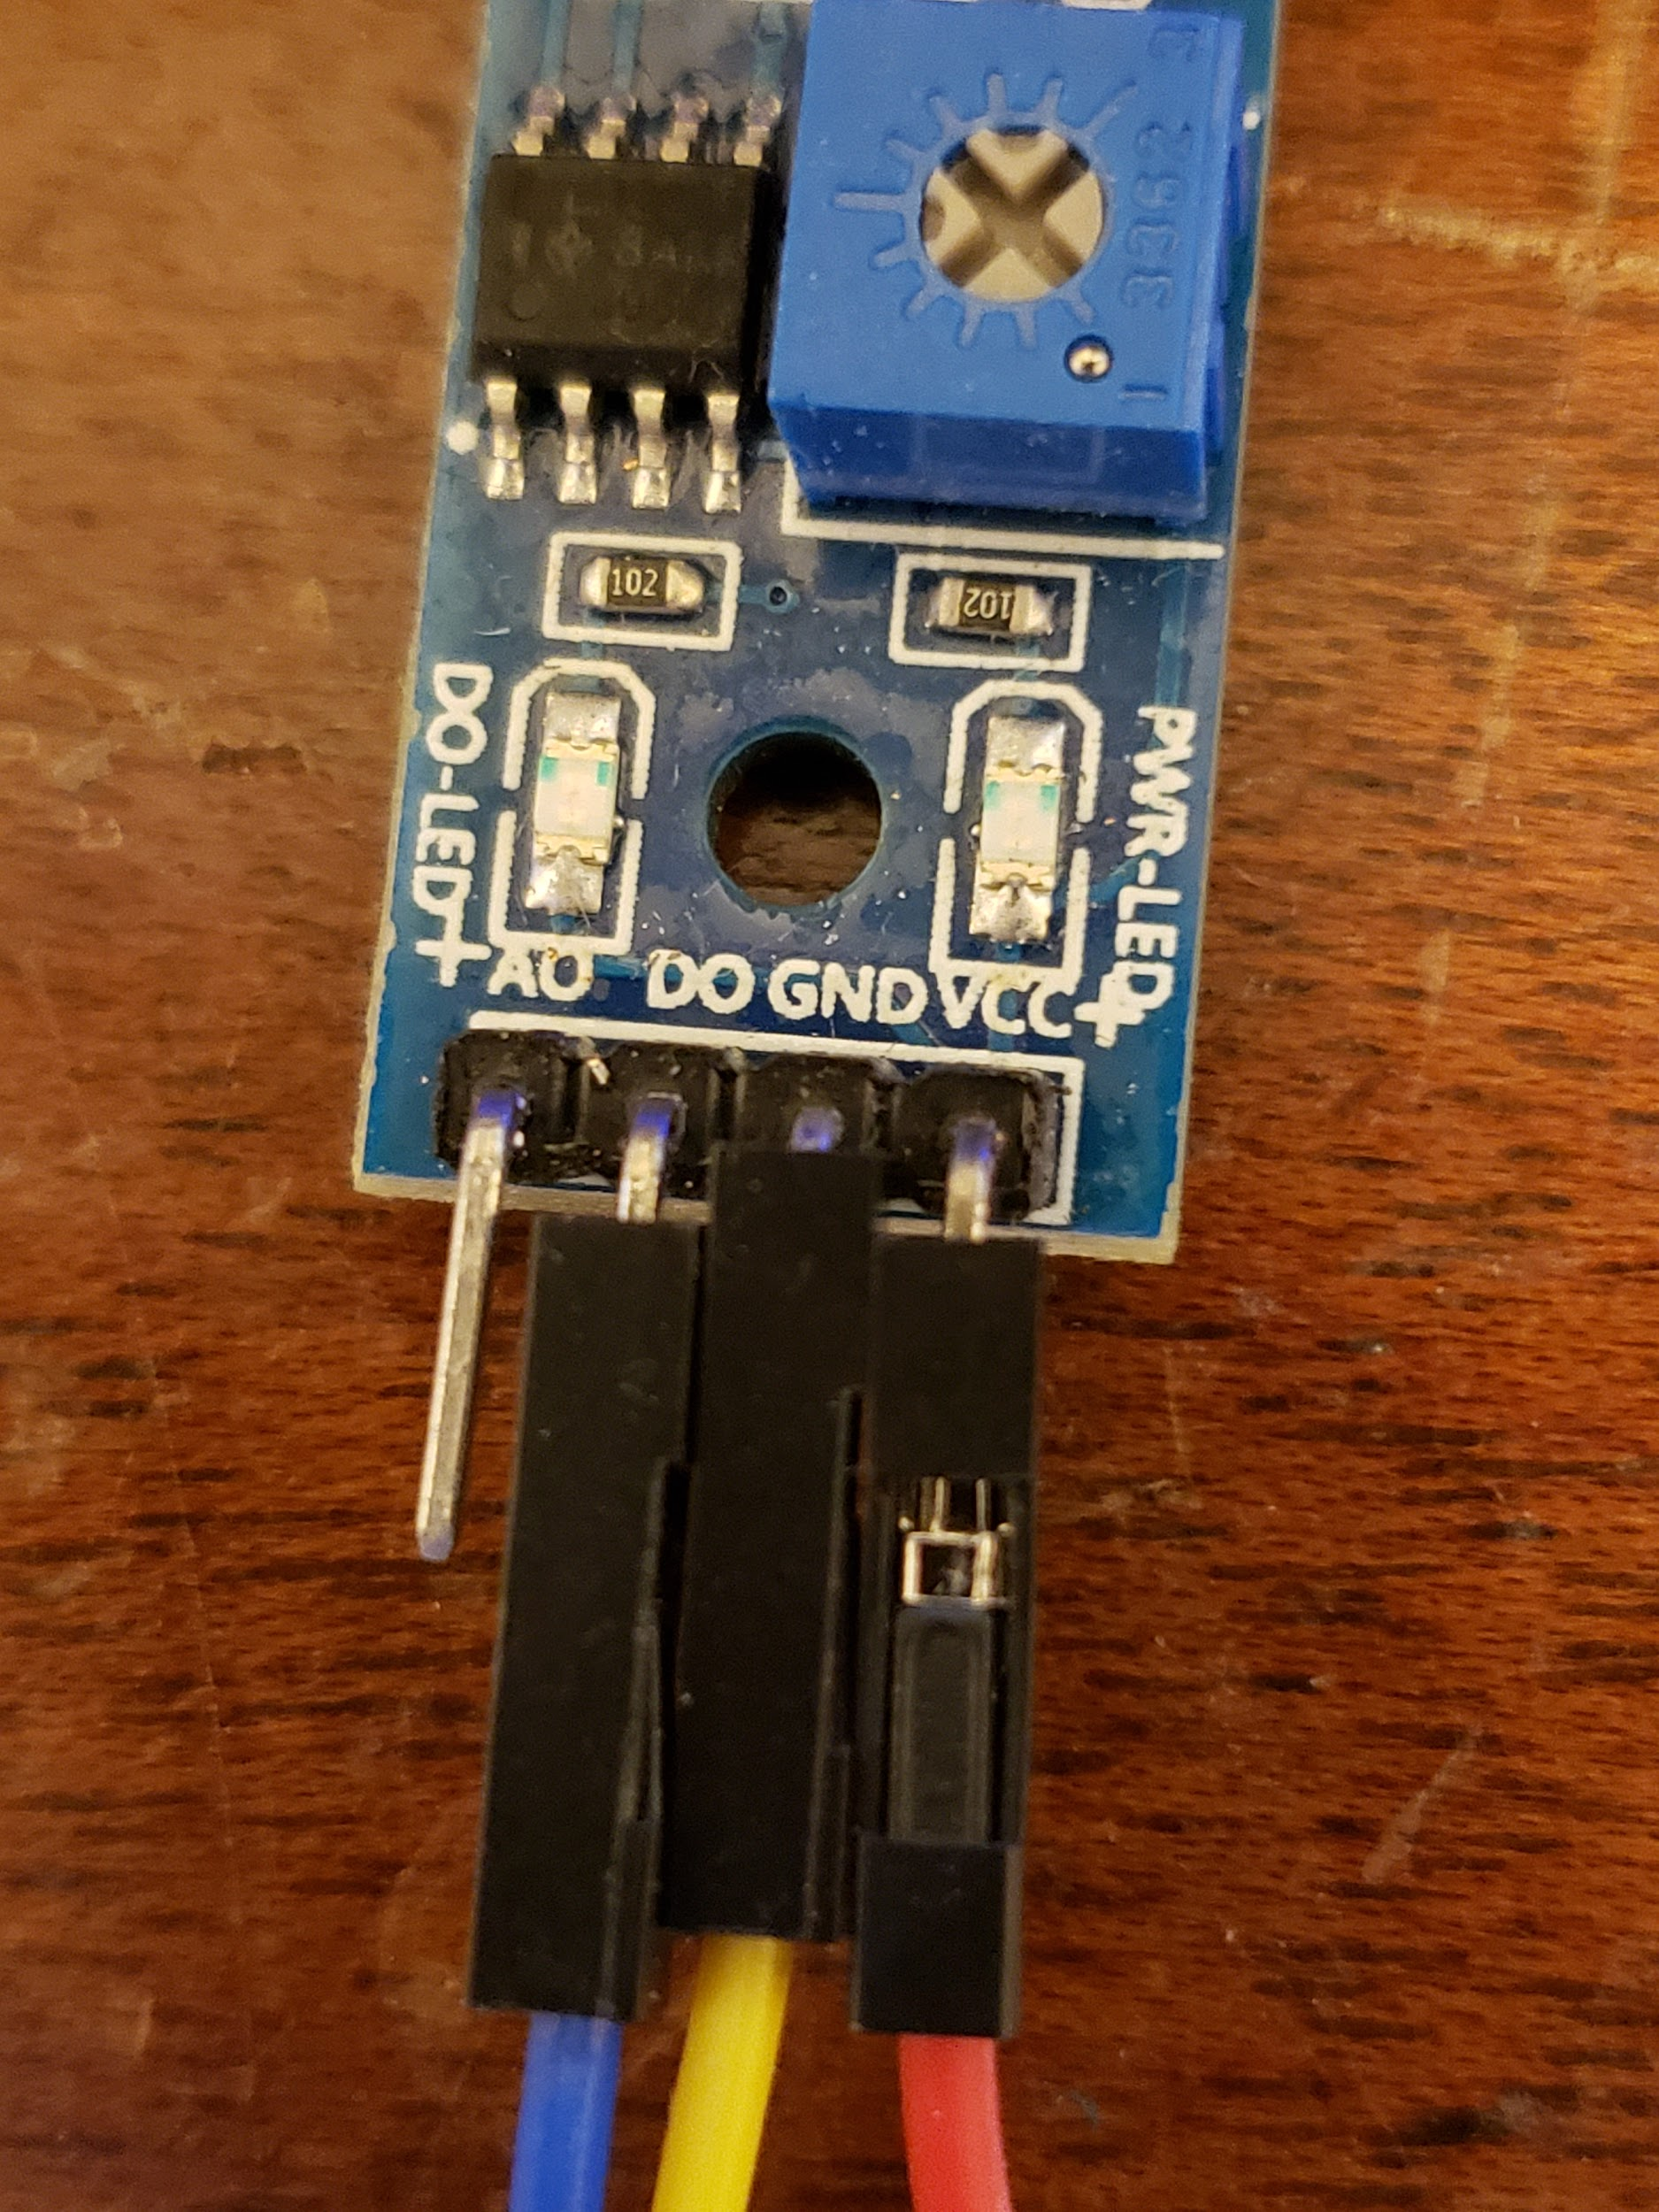

From here we will need to power the breadboard that we are going to connect the light sensor to. For this we will need one female to male jumper cable which we will connect to the positive terminal on the breadboard. It will look like this:

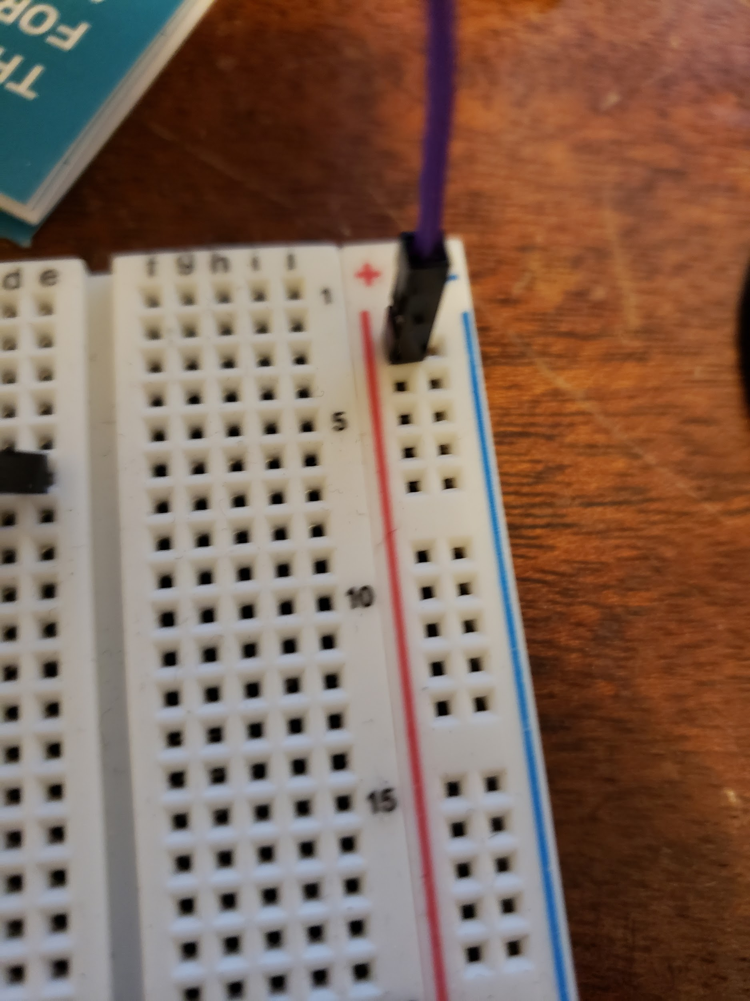

Then we will add a male to male jumper between the positive terminal on this right side of the breadboard to the left side of the breadboard or vice versa depending on the initial setup of the thermometer. It will look something like this:

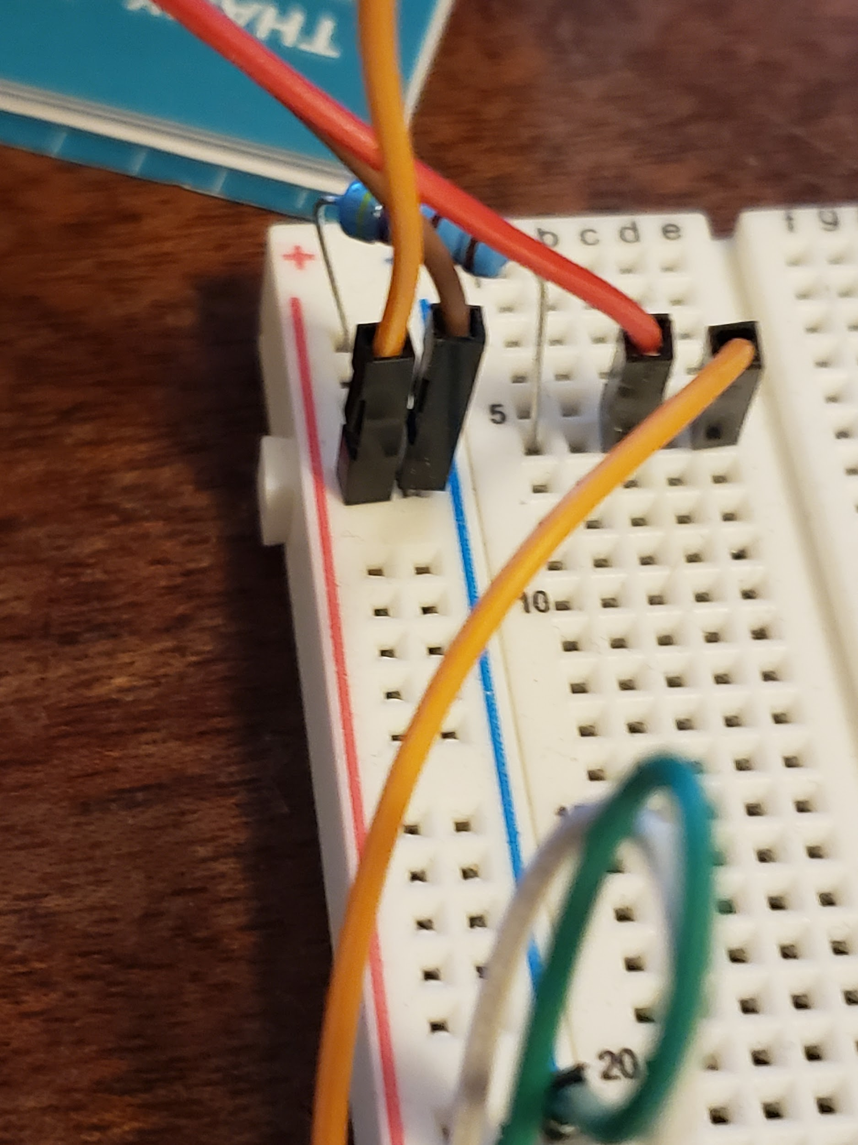

(the orange cable is the cable to be connected to the opposite positive terminal)

With this done, we will now connect the male jumper cable into the positive terminal on the right side which will resemble this:

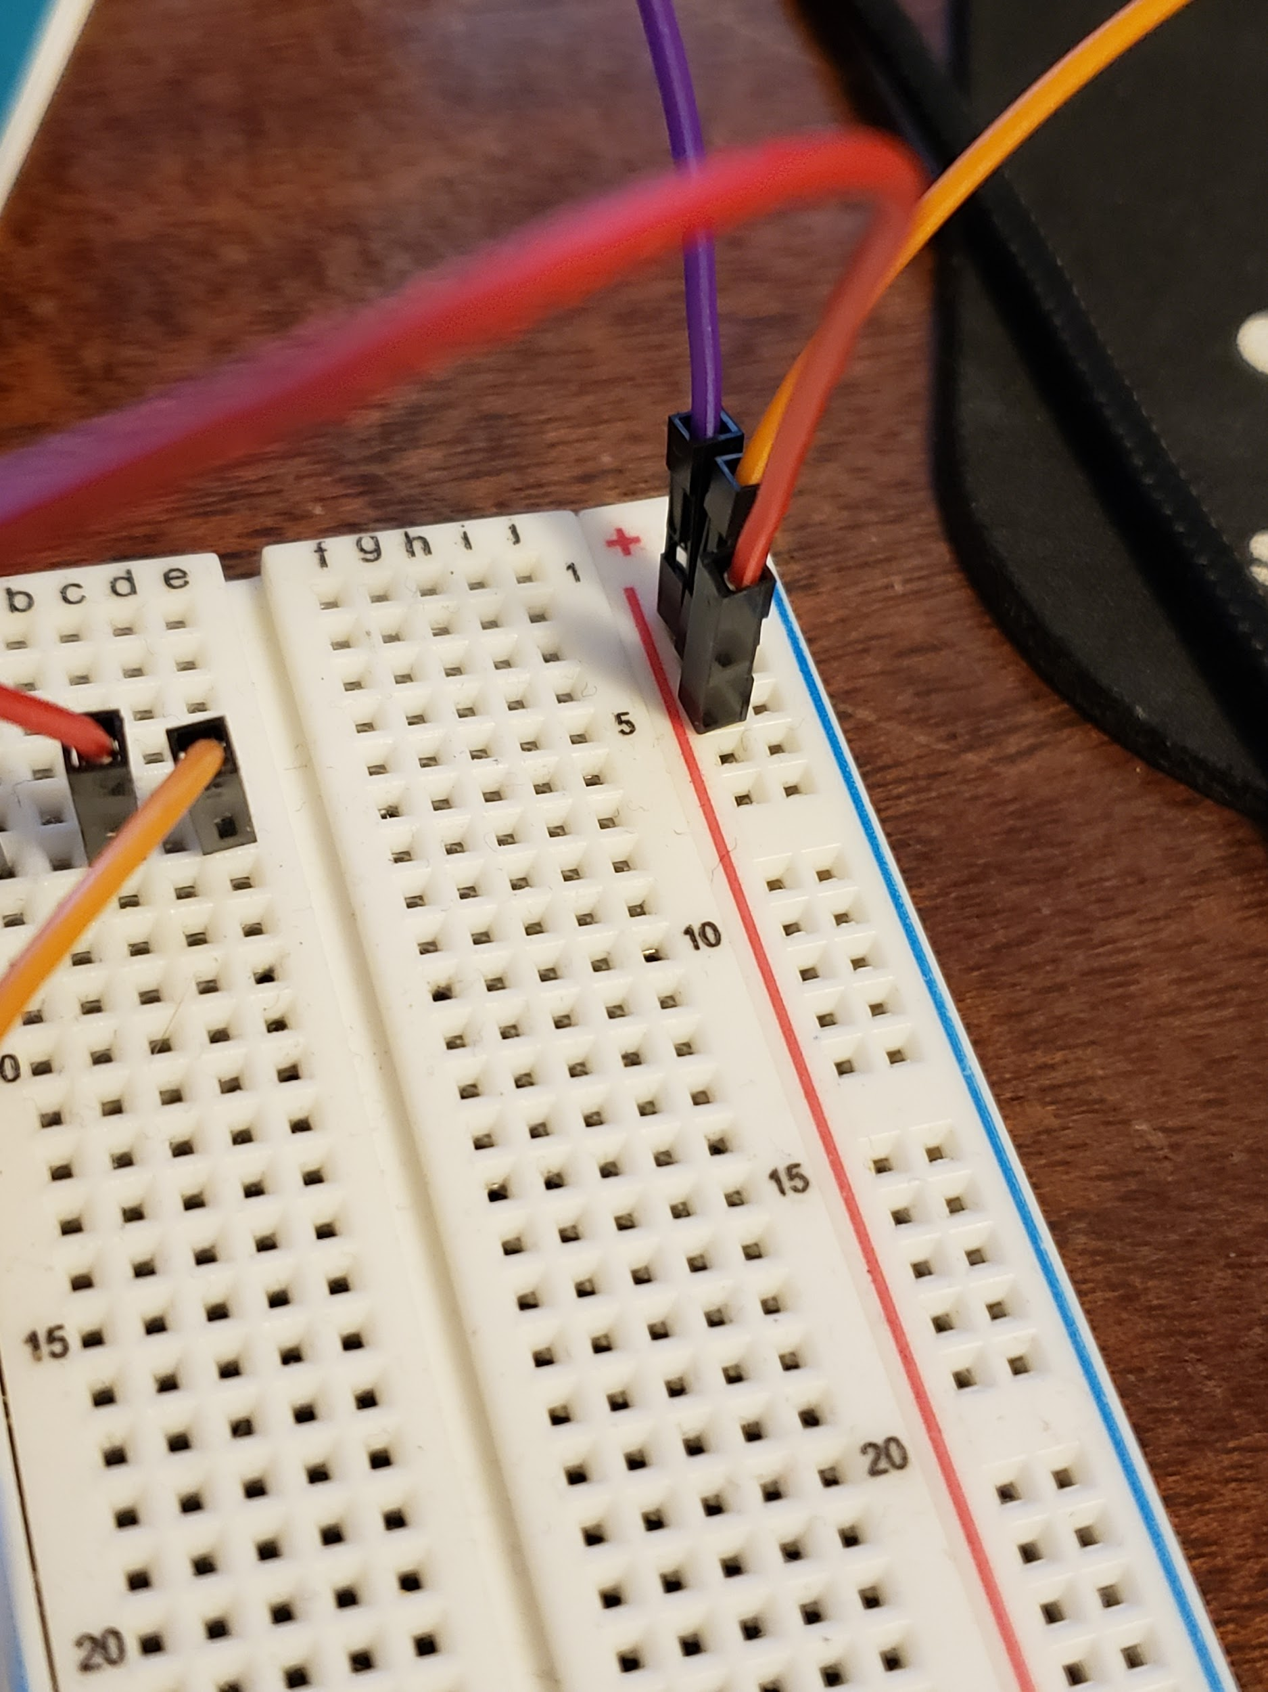

The other two connections for the light sensor will be connected directly into the Raspberry Pi. Starting with the data pin which is connected to the AO pin, this will be connected to a GPIO pin, in my case GPIO 4 or pin 7. Then the ground pin will need to be connected to any ground I chose pin 9 for that. These two steps should look like this:

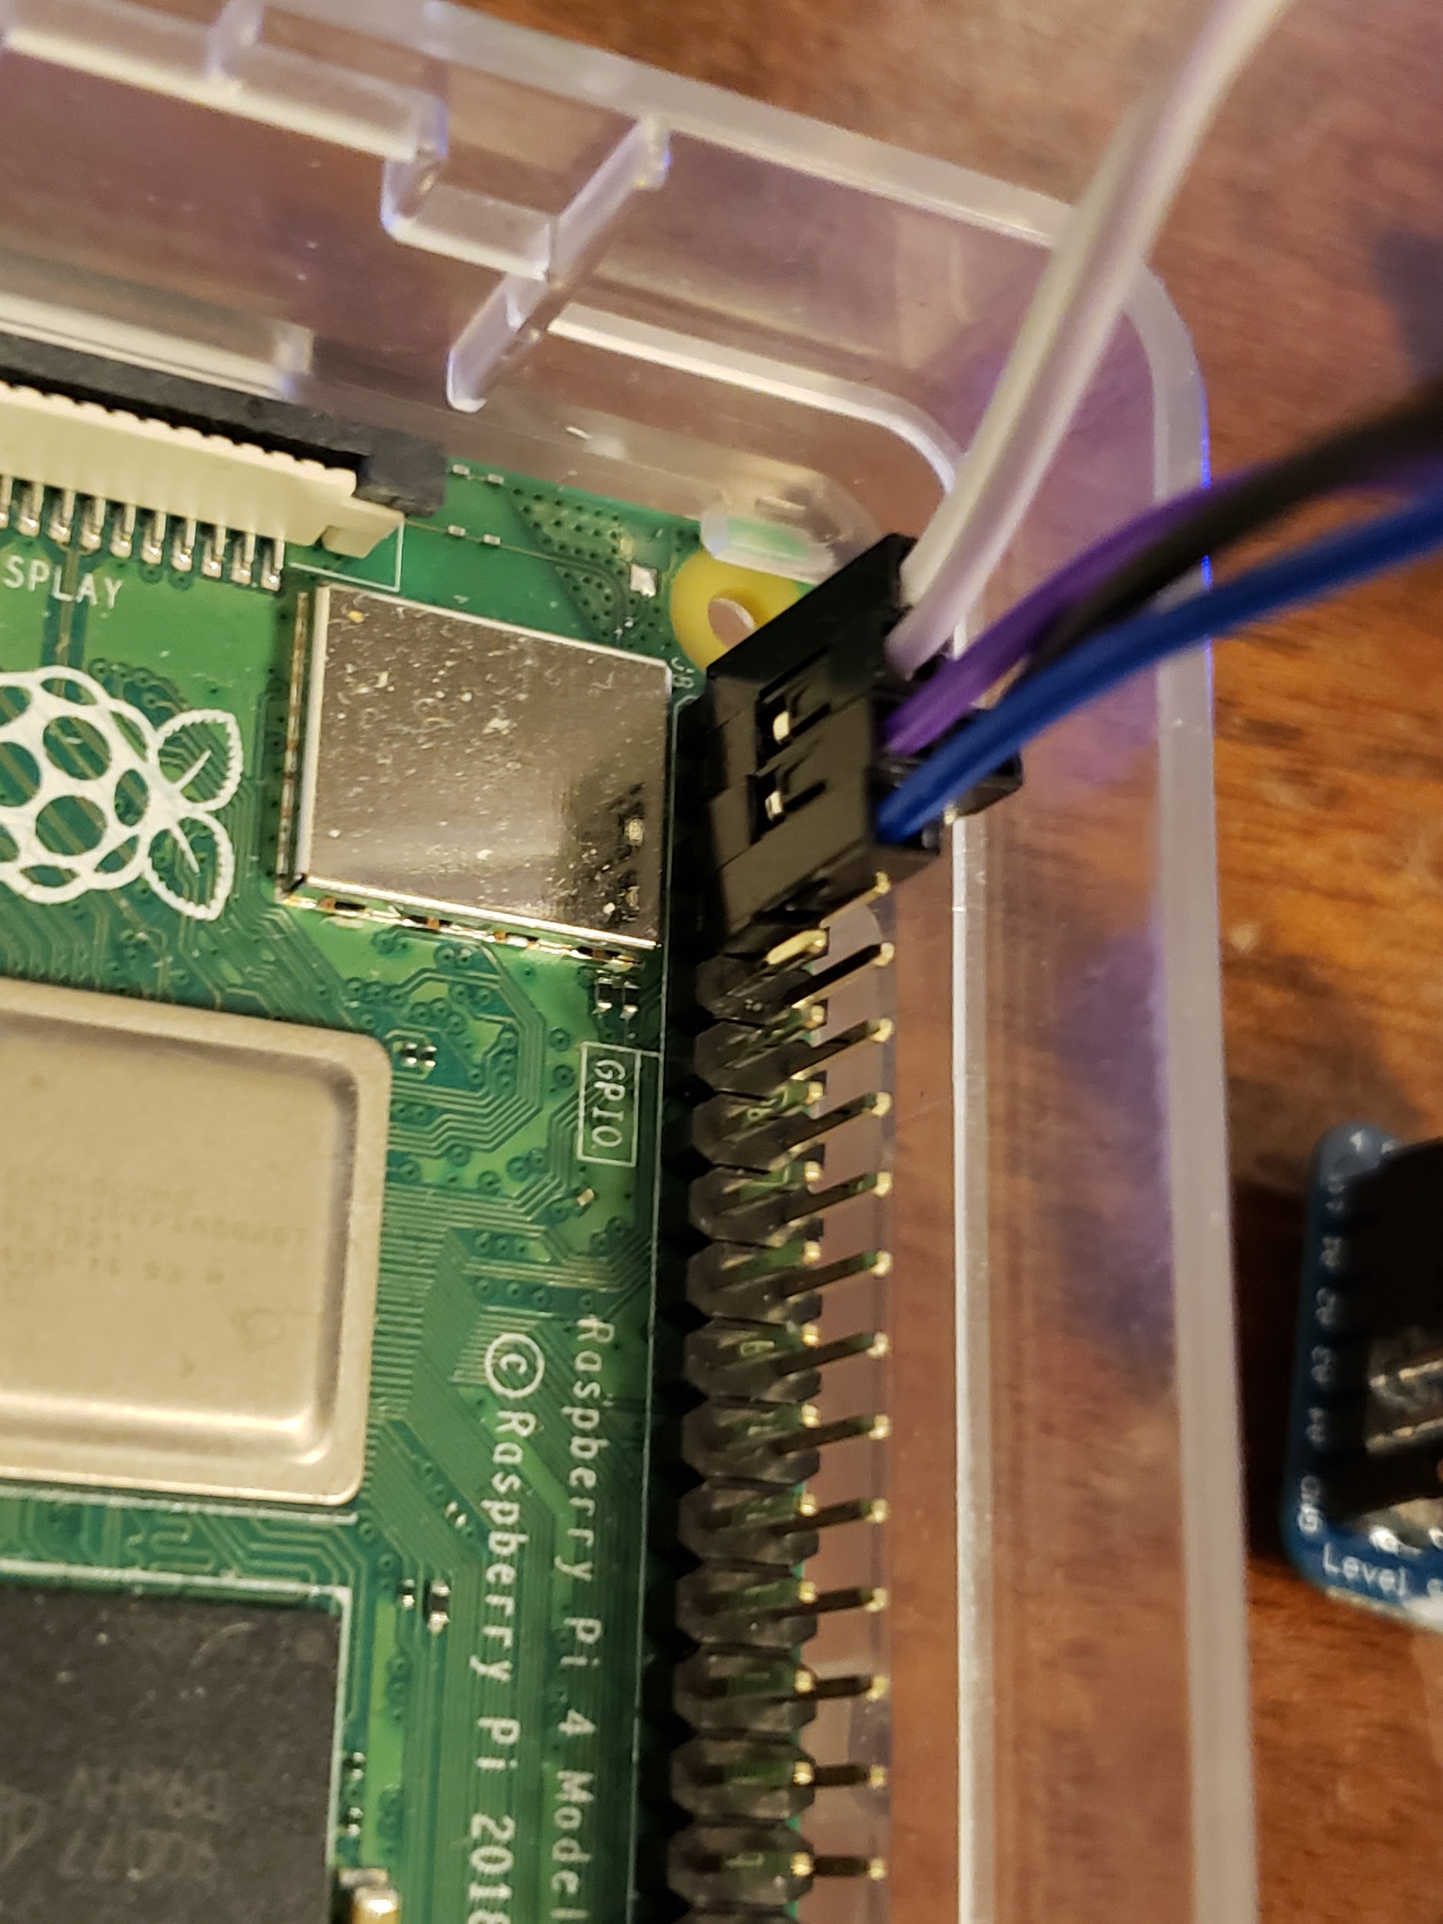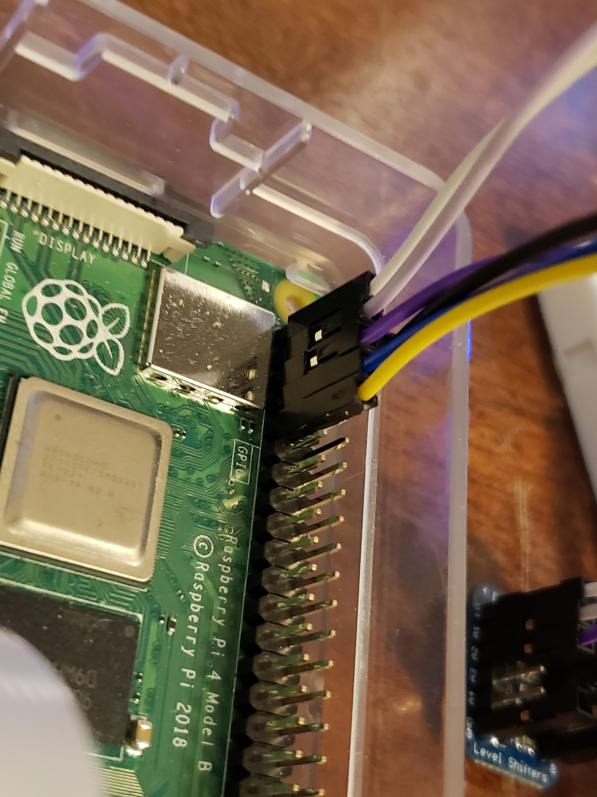

From here we will need to give our breadboard power so we will run a 5V connection from the Raspberry Pi to the breadboard. We will use the cable we connected to the right side of the breadboard from a couple of steps ago. The one I used for this is purple, anyways it should look like this:

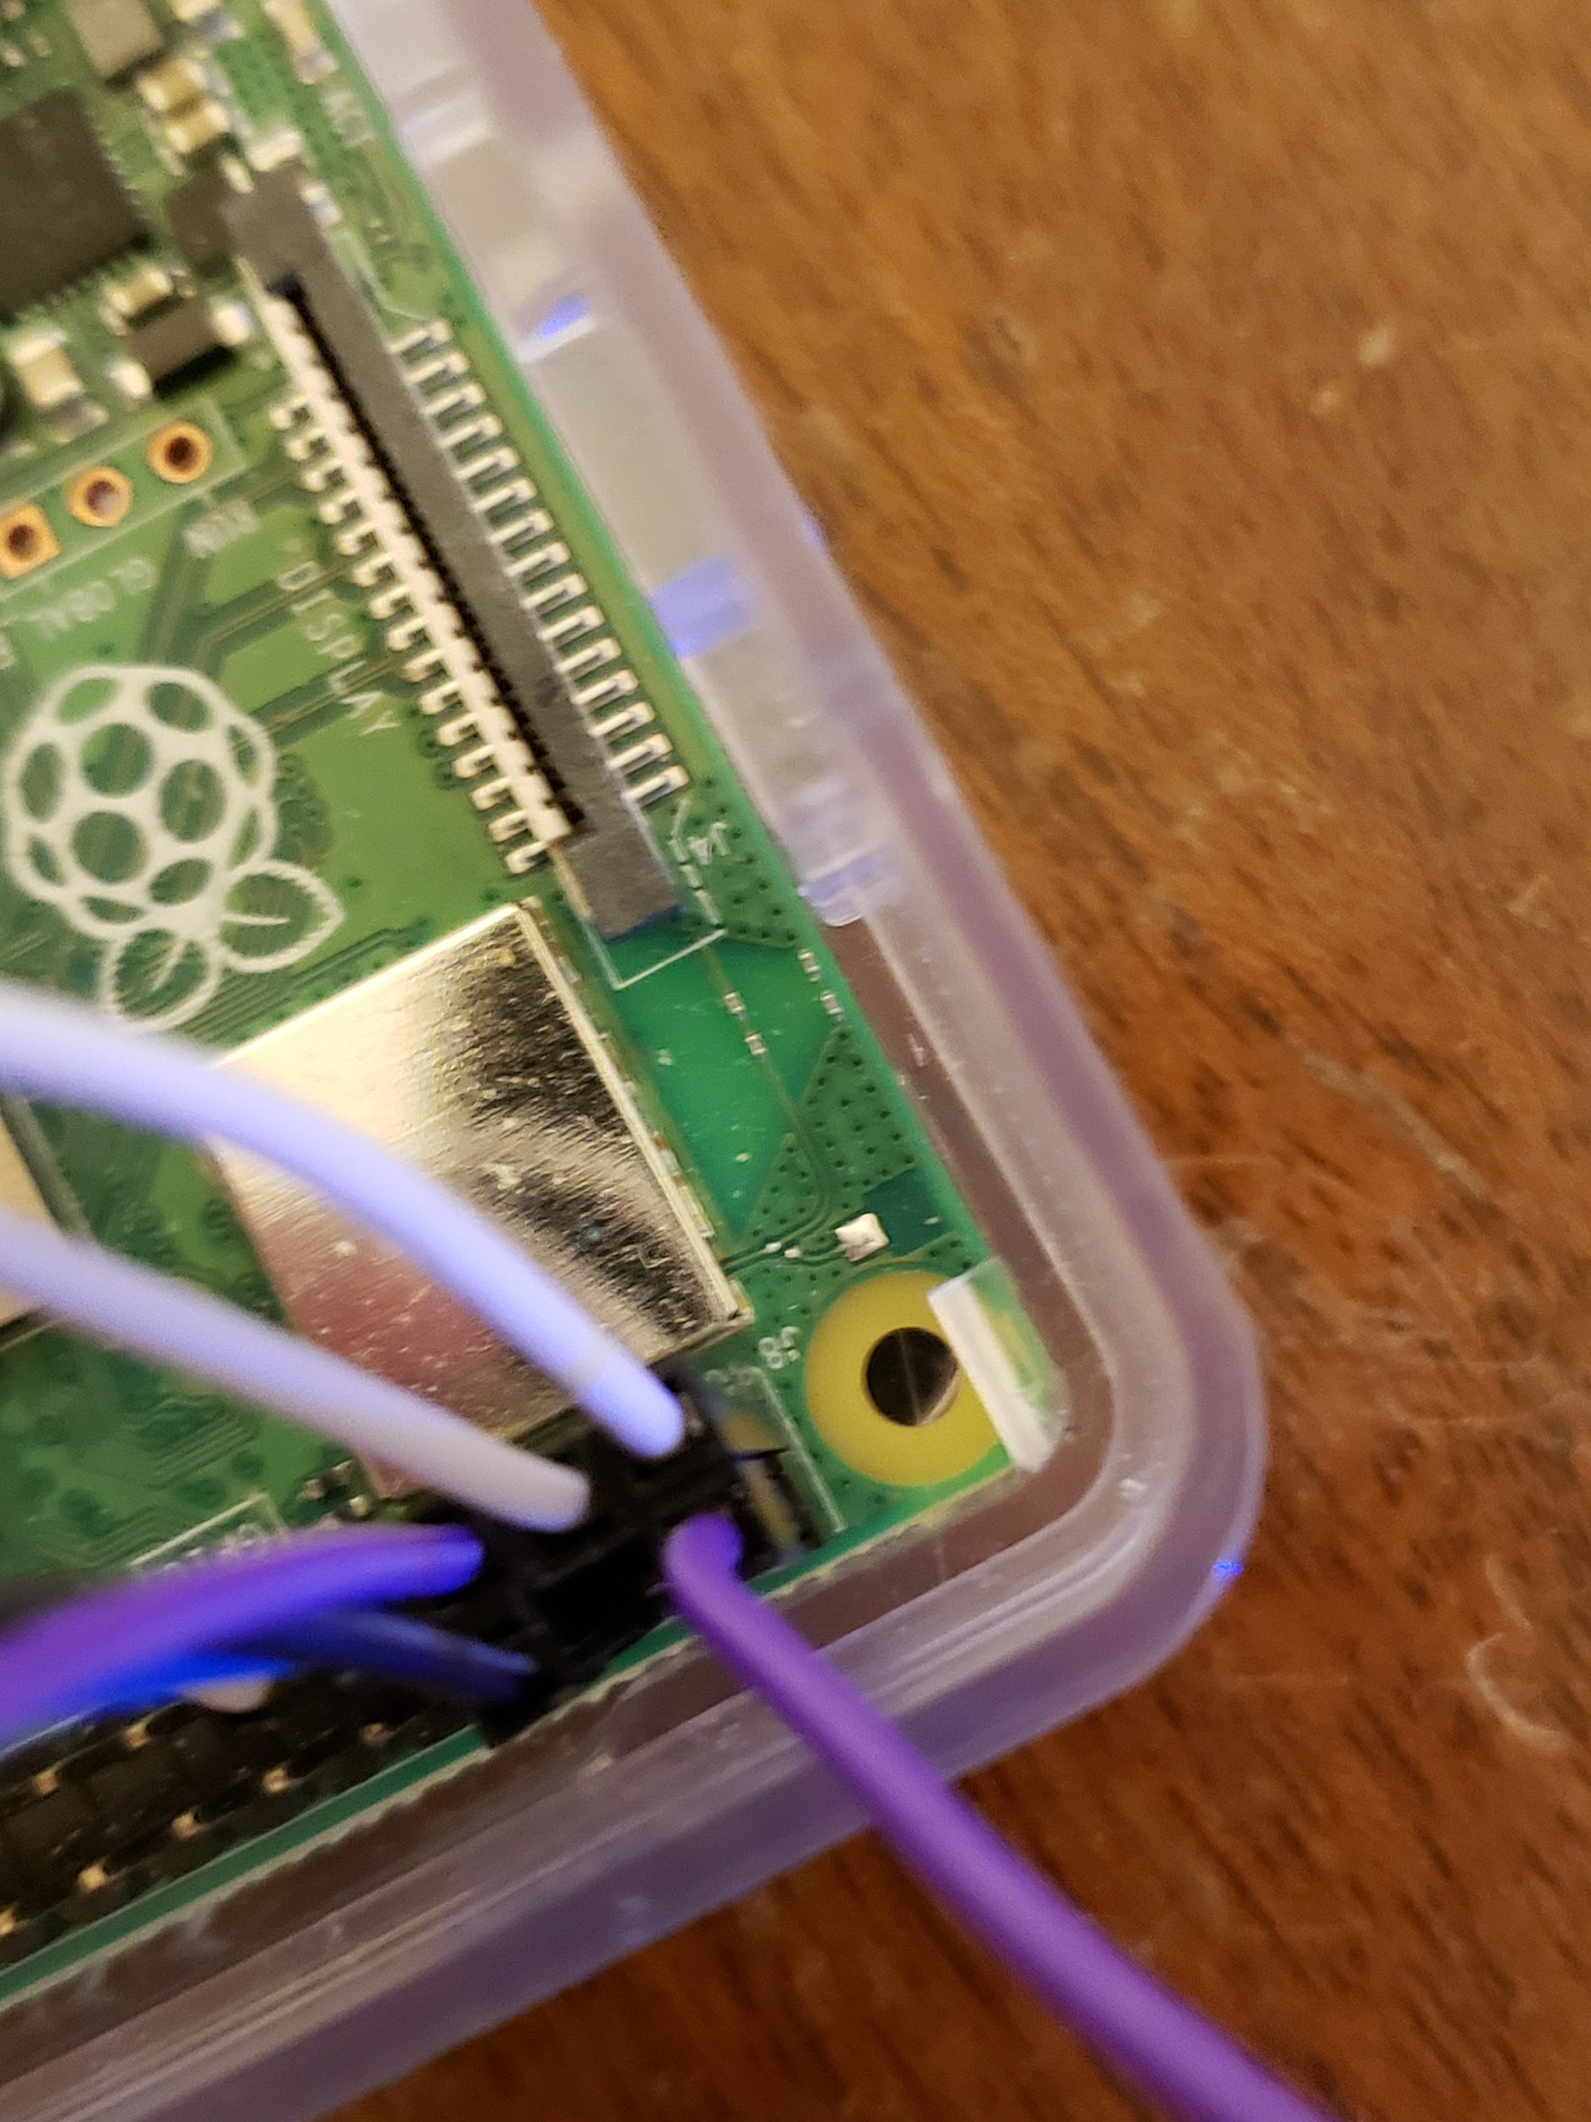 (this is pin 2)

From here we will need to connect the data and ground pins from the thermometer into the Raspberry Pi. I put the data pin into GPIO 17 or pin 11 and the ground into pin 14. These two steps should look like this:

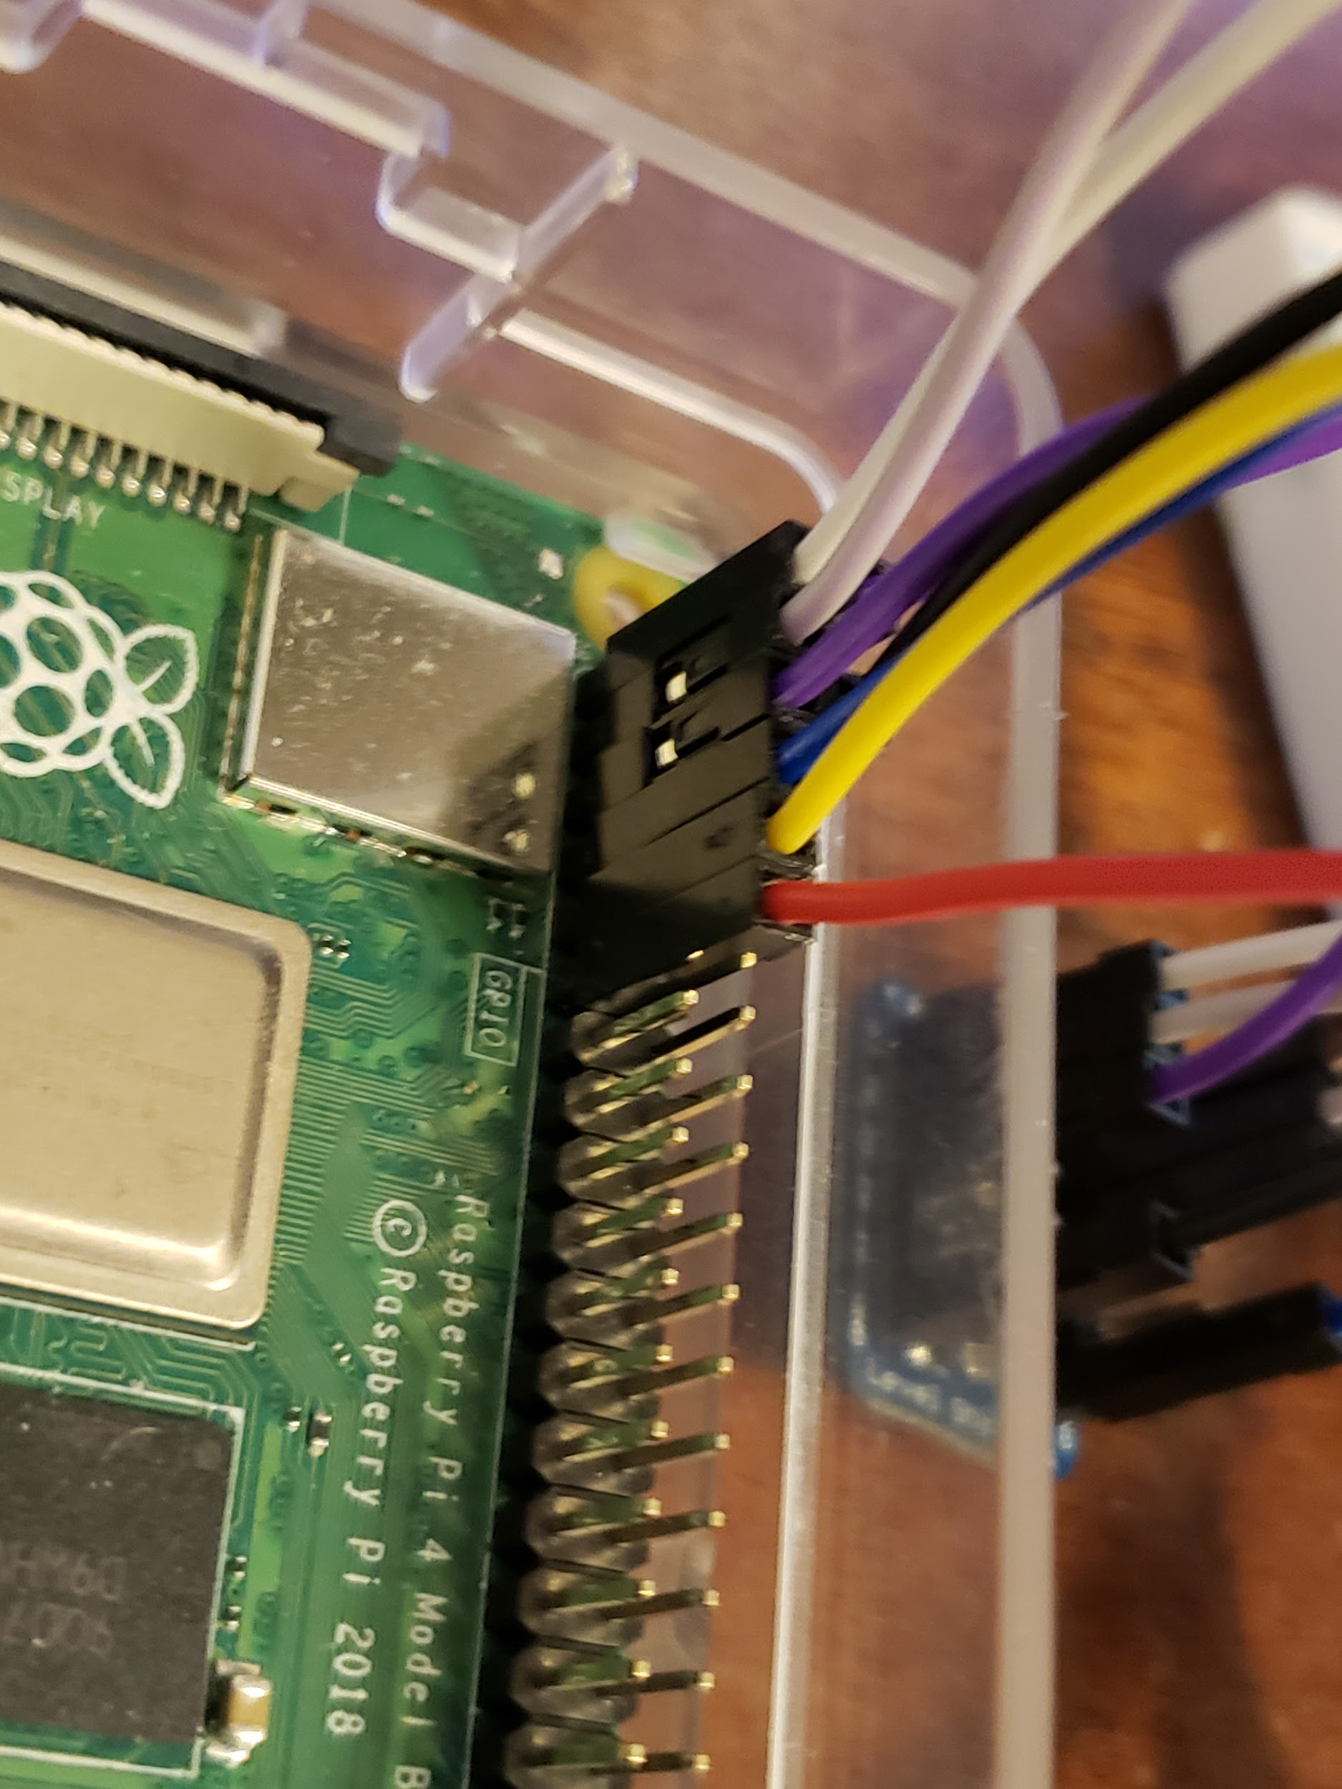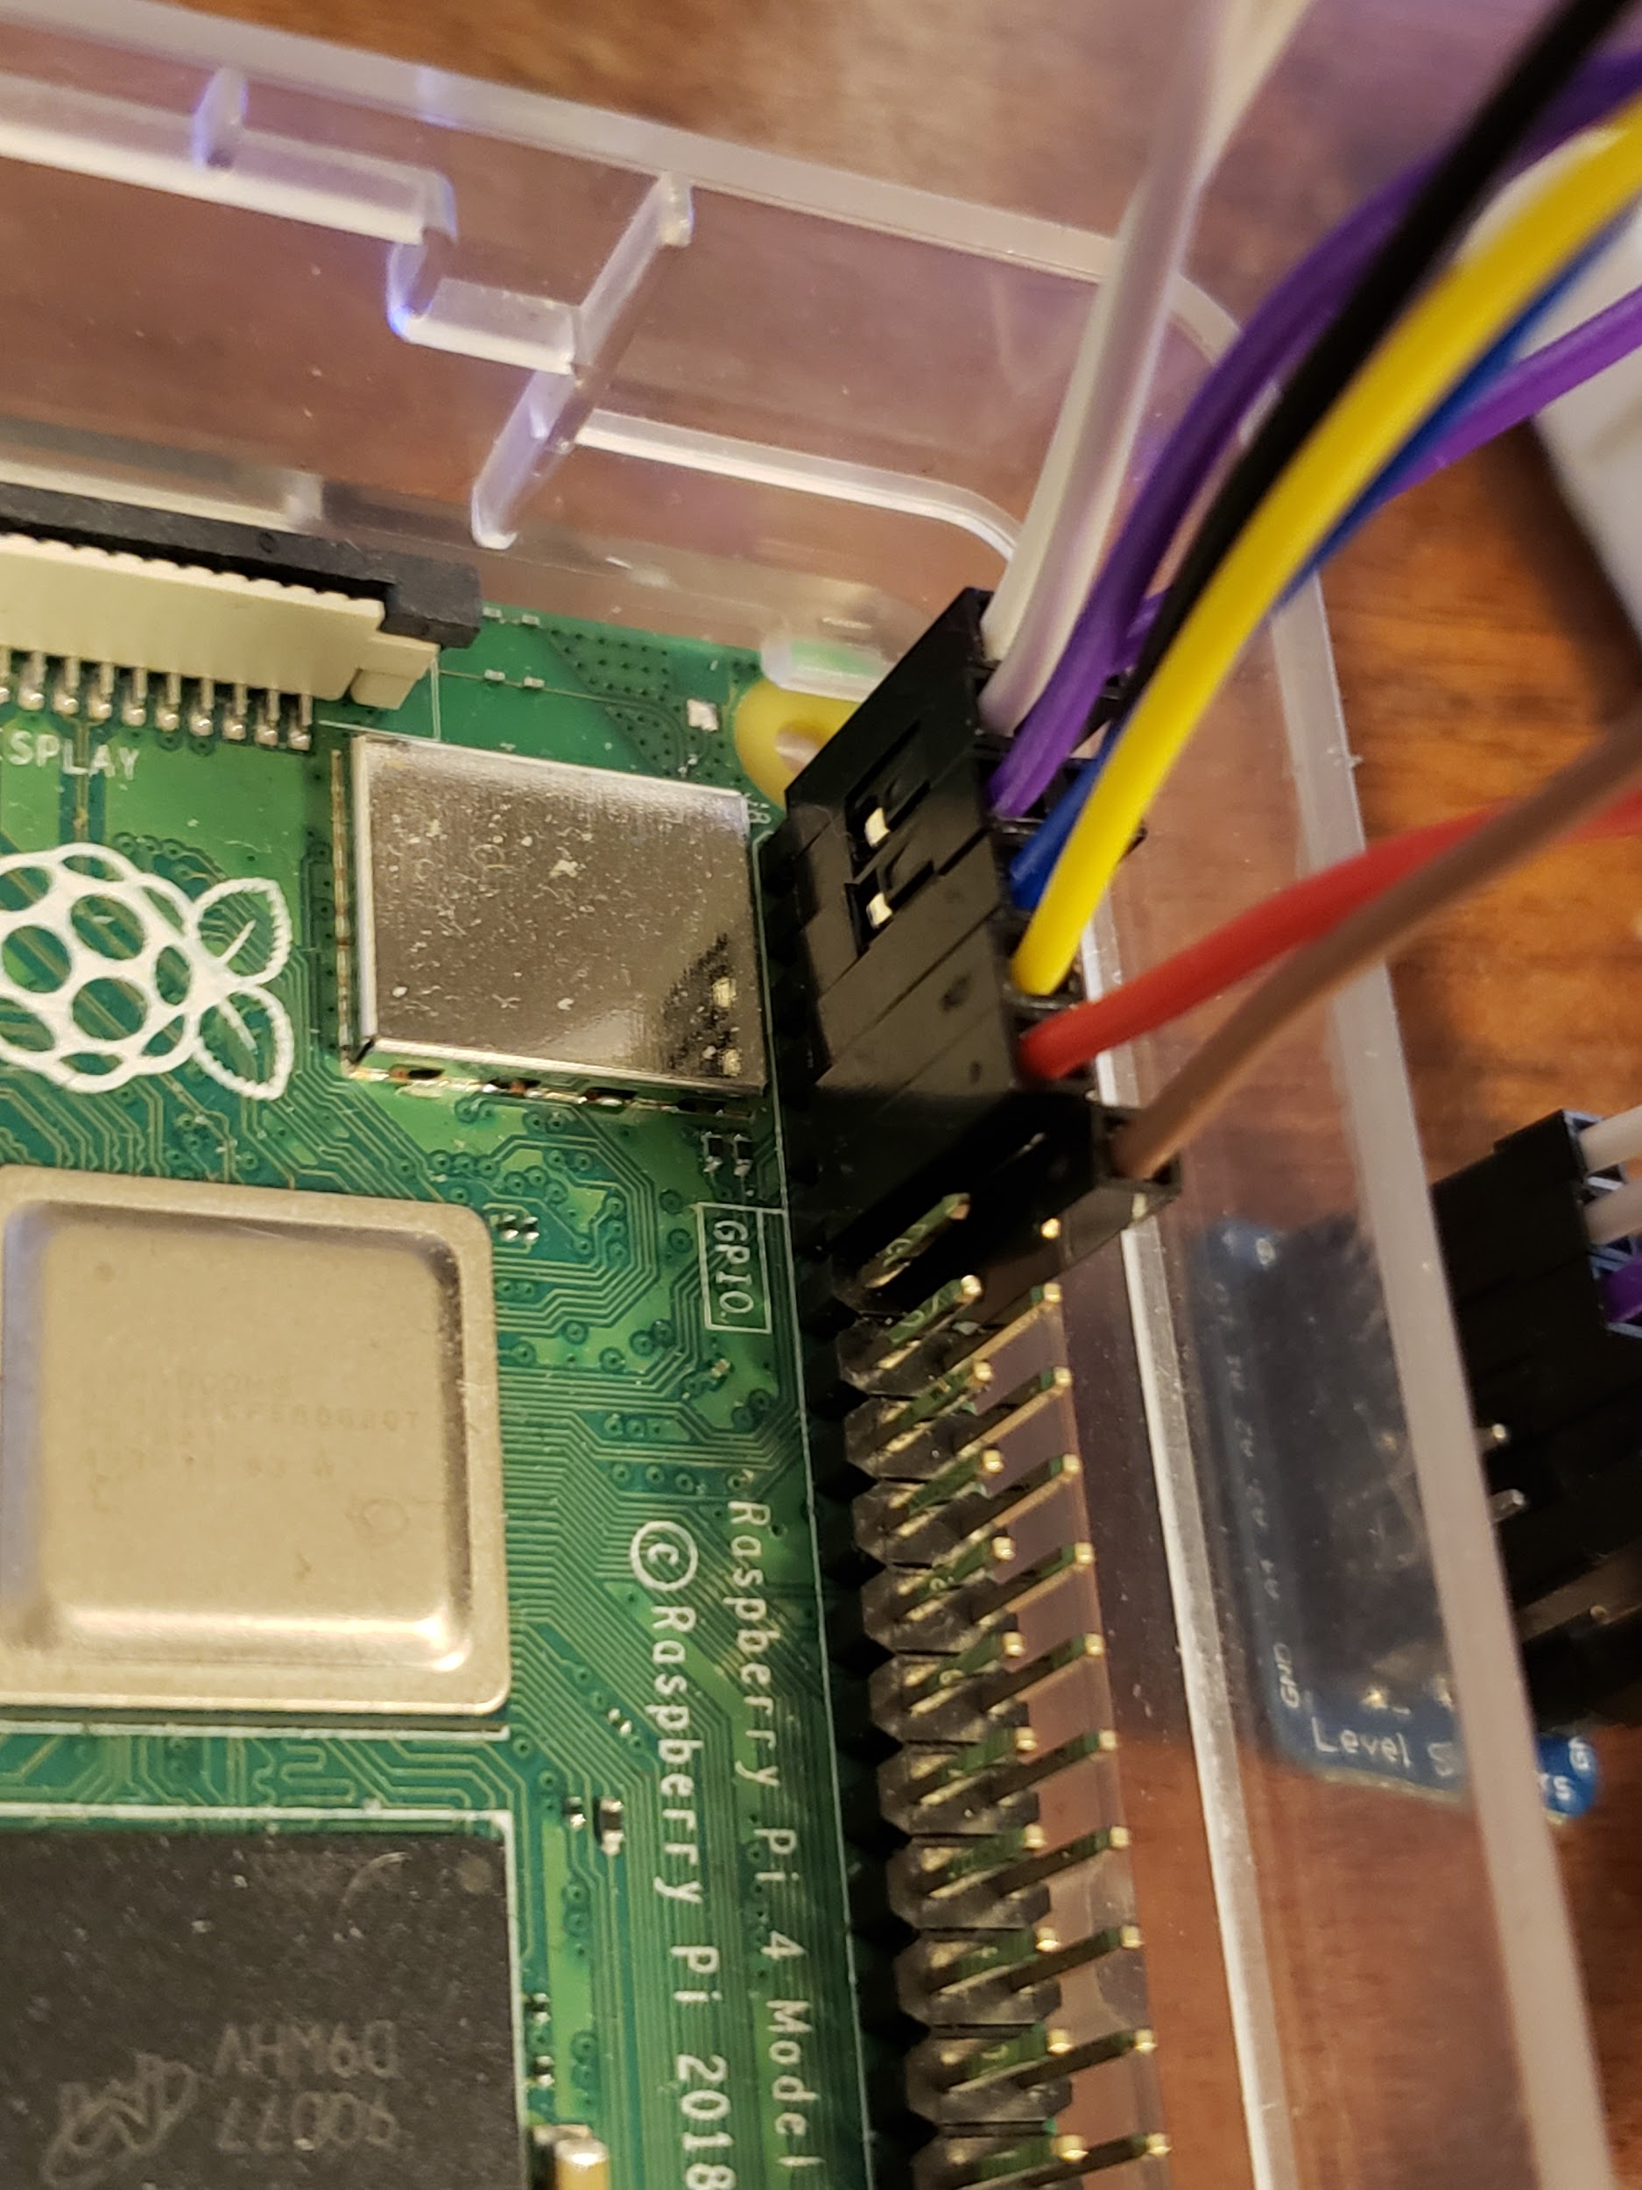

With this done, everything should be wired completely. Feel free to go back and redo steps if need be. We are now ready to code.

**Step Two: Programming**

Assuming the Turbidity Sensor tutorial was completed your Arduino should already have the software needed to send inputs to the Raspberry Pi. This then just requires us to write some simple python code. With all the tutorials done you have everything needed to complete this portion of the project. But I have included the code I wrote to run all the sensors, timestamp them and compile it in a text file. You may run into issues with the turbidity sensor, as you can see in the 6th line of code I have ttyACM0 which is the identity of the sensor. This might be incorrect for your sensor. To make sure it is correct first go to the Arduino IDE then look in the bottom right hand corner to find the serial code for your unit.

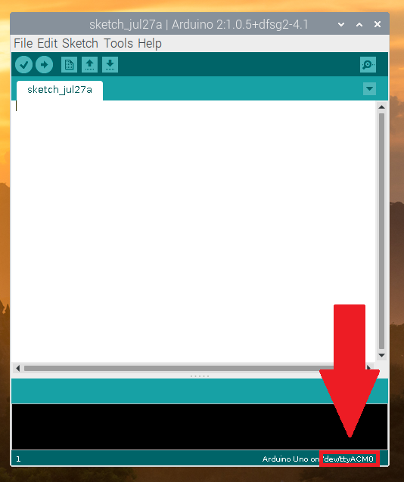

(it is in the red box)

I have included the code below:

*import os, serial*

*from picamera import PiCamera*

*import RPi.GPIO as GPIO*

*import time, threading*

*from datetime import datetime, timedelta*

*ser = serial.Serial('/dev/ttyACM0', 9600) #replace some of this if need be*

*listTime = []*

*listData = []*

*records = open("Records.txt", "w")*

*camera = PiCamera()*

*GPIO.setmode(GPIO.BCM)*

*GPIO.setup(17, GPIO.IN)*

*def sensor():*

*for i in os.listdir('/sys/bus/w1/devices'):*

*if i != 'w1_bus_master1':*

*ds18b20 = i*

*return ds18b20*

*def capture(): #file path is listed below replace if necessary*

*timestamp = datetime.now().isoformat()*

*camera.capture('/home/pi/Documents/Code/Pictures/%s.jpg' % timestamp)*

*def read(ds18b20):*

*location = '/sys/bus/w1/devices/' + ds18b20 + '/w1_slave'*

*tfile = open(location)*

*text = tfile.read()*

*tfile.close()*

*secondline = text.split("\n")[1]*

*temperaturedata = secondline.split(" ")[9]*

*temperature = float(temperaturedata[2:])*

*celsius = temperature / 1000*

*farenheit = (celsius * 1.8) + 32*

*return farenheit*

*def currTime():*

*now = datetime.now()*

*current_time = now.strftime("%H:%M:%S")*

*return current_time*

*def writeFile():*

*records = open("Records.txt", "w")*

*for (times, state) in zip(listTime, listData):*

*records.write(times + " Temp: " + str(state[0]) + " Light State: " + state[1] + " Turbidity: " + str(state[2]) + "\n")*

*records.close()*

*def internalSystem():*

*turbid = "Booting up"*

*if(ser.in_waiting > 0):*

*turbid = ser.readline()*

*serialNum = sensor()*

*data = []*

*data.append(read(serialNum))*

*if GPIO.input(17) == 1:*

*data.append("Dark")*

*else:*

*data.append("Light")*

*if turbid != "":*

*data.append(turbid)*

*listTime.append(currTime())*

*listData.append(data)*

*def runTime(iterations):*

*iterations = iterations + 1*

*if (iterations <= 3):*

*timer = threading.Timer(0.5, runTime, [iterations])*

*internalSystem()*

*timer.start()*

*writeFile()*

*capture()*

*else :*

*print("Conclusion")*

*iterations = 0*

*runTime(iterations)*

With this code in a folder with a text file called Records.txt and a folder called Pictures it should run properly.

**PINS**

